Risk Assessment
Information and guidance

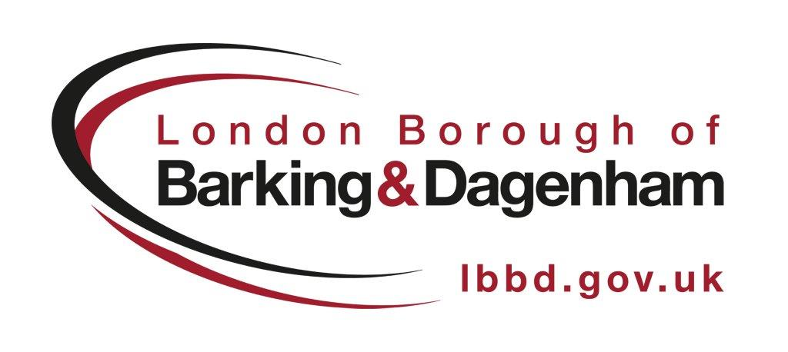

Revised May 2017
Minor Revision Oct 2019

Content

Introduction 3
Training 3
Law 3
Why manage via risk assessment 4
Sensible risk management 4
Who undertakes the assessment 5
Decide how it will be done 5
How detailed 5
When to assess 5
Prioritising actions from your risk assessment 6
Risk Assessment Programme 6
Five steps to risk assessment 6
Step 1 - Identify the hazard 6
Step 2 - Decide who might be harmed and how 7
Step 3 - Evaluate the risks and decide on precautions 8
Step 4 - Record the findings and implement them 8
Step 5 - Review you risk assessment and revise if necessary 9
Risk assessment form 9
How to complete a risk assessment form 10
Simple steps to undertake an assessment 10
Risk matrix (mainly used for more complex assessments) 11
Further assessments 12
Asbestos 12
Control of Substances Hazardous to Health (COSHH) 12
Using computers 12
Stress 12
Fire 12
Water Systems 13
Other building duty holder areas 13
New and expectant mothers 13
Frequently asked questions (FAQ’s) 16
Useful contacts 16

Introduction

The purpose of this document is to provide guidance and tools to help you understand what you need to do to assess and control risks in the workplace and comply with health and safety law. There is a legal requirement to undertake risk assessment.

This guidance should be read in conjunction the Health and Safety Executives (HSE) Five Steps to a Risk Assessment (INDG163): www.hse.gov.uk/pubns/indg163.pdf.

A risk assessment is about identifying sensible measures to control the risk in the workplace. Think about how accidents and ill health could happen and concentrate on real risks - those that are most likely and which will cause the most harm. It requires us to take time to stop and consider the risks associated with our jobs so we can be safer and healthier.

If you are unclear on what is required of you to meet your obligations under the LBBD Health and Safety Policy and Arrangements, then visit the Health and Safety section on the Council intranet or contact the HR Service Centre for further advice and guidance.

Training

For LBBD Corporate staff:
Risk assessment training is available on i-Learn. Simply logon to i-Learn https://lbbd.learningpool.com/login/index.php and search risk assessment in the course search box on the right-hand side of the home page.

i-Learn provides you with a range of e-learning course. For new accounts please enter the following details:
Username - Your LBBD email
Password - welcome

Bespoke risk assessment workshops can be delivered, course charges apply. Please contact Learning and Development to arrange.

For Schools staff:
Unfortunately, I-Learn training is not yet available to schools. Please contact LBBD Learning and Development Team: learningdevelopment@lbbd.gov.uk for information on how to book a tutor led course or to discuss your requirements.

Law

The Management of Health and Safety at Work Regulations 1999 require you to assess risks to the health and safety of anyone that may be affected by your activities. The regulations also require you to examine what in your work could cause harm to others so you can decide whether you have done enough or need to do more.

This guide looks only at the risk assessment provisions likely to affect the council where common risks are encountered.

It does not cover regulations dealing with highly specialised risks such as major hazards, e.g. ionising radiation (possibly found in surveying tools). Please see the further assessment section for a list of areas where a more detailed risk assessment may be required.

Some regulations do not require you to risk assess everyone. For example, the Display Screen Regulations require you to assess workstations for health and safety risks to your employees and agency workers, but not for members of the public. Similarly, the Manual Handling Operations Regulations 1992 require you to assess risks to yourself and your employees but not to members of the public.

Risk assessment provisions in other regulations covering specific hazards, such as hazardous chemicals, often give more detail about what you need to assess and may require particular control measures. For example, the Control of Substances Hazardous to Health Regulations 2002 (COSHH) requires you to conduct COSHH assessments for any chemical/hazardous substance that may cause harm or ill health to employees and/or members of the public.

Why manage via risk assessment

Risk Assessment is a technique that helps to prevent accidents and ill health. It encourages managers and employees to think about what could go wrong so that they can control the situation before accidents or ill health occurs.

A risk assessment programme can help to improve operational efficiency, offer financial savings and maintain good reputation. It enables us to reduce costs associated with accidents and ill health and help decide on priorities, highlight training needs and assist with quality assurance.

Managing health and safety via risk assessment is not only good practice it is a legal requirement.

Sensible risk management

Risk management is about taking practical steps to protect people from real harm and suffering. You are probably already taking steps to protect employees and others, but your risk assessment will help you decide whether you have covered all you need to. See the Health and Safety Executives Sensible Risk Management webpage for further information on taking a sensible approach to risk management http://www.hse.gov.uk/risk/principles.htm.

Who undertakes the assessment

A person who has knowledge of the task or job to be assessed should undertake the risk assessment. This would normally be a line manager or supervisor and will be dependent on the depth of knowledge needed to perform the job. You may need extra help if the risks are complex. Involve employee representatives in the risk assessment process where possible and consult on changes.

Decide how it will be done

Consider whether the risk assessment should be carried out on an area basis or function by function, making sure the approach is consistent.

How detailed

Keep the risk assessment simple and keep it sensible. Focus on the significant risks. The regulations require the risk assessment to be “suitable and sufficient”. In deciding the amount of effort you need to put into the assessment, you need to judge whether the hazards are significant and whether you have adequate precautions or control measures in place to keep the risks acceptable and within the law.

You don’t have to assess every task and can make one assessment if it covers a group of employees or sites with the same activities. A generic assessment will be sufficient if that task applies to groups of people completing similar tasks. You may need to carry out a more detailed risk assessment if it is a higher risk activity. Please see the further assessment section for a list of areas where a more detailed risk assessment may be required.

When to assess

The Health and Safety Executive (HSE) says risk should be assessed "every time there are new machines, substances and procedures, which could lead to new hazards." An employer should carry out a risk assessment: whenever a new job brings in significant new hazards.

If an employee’s circumstances change?
If an employee’s circumstance change you will need to review your risk assessment to check whether you need to make any changes in the measures you take to control risk. This is particularly important when, for example, people return to work following surgery etc, new or expectant mothers or if an employee develops a disability. Most employers will be able to find a way to make adjustments to work that are suitable for their employees.

Prioritising actions from your risk assessment

You may find that there are several issues which need action, so you need decide on your priorities for action. When thinking through your priorities, think about the serious risks first. Having identified the priorities, you need to decide on the controls which you will put into place. In doing so, think about the following:

- long-term solutions to those risks with the worst potential consequences
- long-term solutions to those risks most likely to cause accidents or ill health
- whether there are improvements that can be implemented quickly, even as a temporary solution until more reliable controls are in place

Remember, the greater the risk the more robust and reliable the control measures will need to be.

Risk Assessment Programme

Where there are a number or risk assessment within your service area to develop/review it may be useful to develop a risk assessment review programme. A risk assessment review programme will enable you to plan your assessments and subsequent reviews. As a suggestion, you may find it helpful to keep all your safety documentation together in one place. This means it will be close at hand if you need to refer to it.

Five steps to risk assessment

This section should be read in connection with the Health and Safety Executives (HSE) Five Steps to Risk Assessment http://www.hse.gov.uk/pubns/indg163.pdf. The HSE recommends that you follow the five steps approach which is a straightforward method in assessing risk. These steps are:

Step 1 Identify the hazard
Step 2 Decide who might be harmed and how
Step 3 Elevate the risks and decide on precautions
Step 4 Record the findings and implement them
Step 5 Review you risk assessment and revise if necessary

Details on what to consider when following the HSE’s five steps:

Step 1 - Identify the hazard
One of the most important aspects of your risk assessment is accurately identifying the potential hazards in your workplace.

A good starting point is to:
- Walk around your workplace and think about any hazards.
- Discuss with employees and/or their representatives; what is it about the activities, processes or substances used that could injure your employees or harm their health.
- Ask your employees what they think the hazards are, as they may notice things that are not obvious to you and may have some good ideas on how to control the risks.
- Check manufacturer’s instruction and data sheets as they may help to spot hazards associated with specific types of equipment or tools.
- Accident reports and any incidences of ill health related to work may be useful too.

Some examples:
- Hazardous substances and hot liquids
- Vehicles
- Working with machinery
- Tools and equipment
- Human factors
- Electricity
- Dust/fumes
- Manual handling
- Noise
- Poor lighting
- Working at height
- Work related stress
- Asbestos

Remember, the greater the hazard the more robust and reliable the measures to control the risk of an injury occurring will need to be.

Step 2 - Decide who might be harmed and how
For each hazard you need to be clear about who might be harmed; it will help you identify the best way of controlling the risk. That doesn’t mean listing everyone by name, but rather identifying groups of people (e.g. people working in the storeroom or passers-by). Remember, some employees may have particular requirements, e.g. new and young employees, migrant workers, new or expectant mothers, people with disabilities, temporary employees, visitors, contractors/maintenance workers, homeworkers and lone workers.

- Ask your employees/employee representatives if there is anyone you may have missed.

- If you share a workplace with another service/business, consider how your work affects others and how their work affects you and your employees. Talk to each other and make sure controls are in place.

Step 3 - Evaluate the risks and decide on precautions
Consider how likely it is that each hazard may cause harm, taking a sensible approach. This will determine whether you need to do more to reduce the risk. Things to consider:
- Are the risks adequately controlled?
- Do you meet legal requirements and council standards?
- Are you following relevant guidance?
- Is the practiced method to a good standard?
- Have risks been reduced as far as reasonable practicable?
- Have adequate instructions and training been provided?
- Are the systems and procedures adequate?
- Could the current system be improved for efficiencies?

Look at what you’re already doing and the control measures you already have in place. Ask yourself:
- Can the hazards be eliminated? (sensibly)
- If not, how can I control the risks so that harm is unlikely?

Practical steps may include:
- trying a less risky option e.g. substituting a hazardous substance with one that causes less harm
- preventing access to the hazards;
- organising your work to reduce exposure to the hazard e.g. job rotation
- issuing protective equipment;
- providing welfare facilities such as first aid and washing facilities
- involving and consulting with workers.

Reference to other documents and manuals such as the council’s health and safety policies, procedures and guidance is acceptable if it helps with simplicity of work and understanding. Manufacturer’s instructions may also provide information. These may already list hazards and precautions so you won’t need to repeat the contents again.

Involve your employees, so you can be sure that what you propose to do will work in practice and won’t introduce any new hazards.

Where the nature of your work changes fairly frequently or the workplace changes and develops (e.g. a construction site), or where your employees move from site to site, your risk assessment may have to concentrate more on a broad range of risks that can be anticipated.

Step 4 - Record the findings and implement them
Record your findings using the risk assessment template. The risk assessment should be simple and focus on controls.

You need to ensure you effectively communicate the risk assessment to employees, and potentially others who may be affected by the outcomes/controls such as contractors. It is very important that employees affected by the risk assessment are informed of the findings and any action measures that need to be taken if a problem is identified.

Your risk assessment must be suitable and sufficient. It should show that:
- a proper check was made
- you asked who might be affected
- you dealt with all the obvious significant hazards, taking into account those involved
- the precautions are reasonable, and the remaining risk is low
- you involved your employees or their representatives in the process

Improving health and safety need not cost a lot. Failure to take simple precautions can cost you a lot more if an accident does happen.

Step 5 - Review you risk assessment and revise if necessary
You need to make sure your risk assessment stays up to date. At a minimum, you should consider reviewing your risk assessments annually to ensure they are still effective. You should review your risk assessment sooner that the planned review date if:
- it is no longer valid
- there has been a significant change
- an accident, incident or a case of ill health has occurred

On review ask yourself and consider:
- Have there been any significant changes?
- Are there improvements you still need to make?
- Have your employees spotted a problem?
- Have you learnt anything from accidents or near misses?

Remember your workplace will change over time. You are likely to bring in new equipment, substances and procedures. There may be advances in technology. You should review your assessment if any of these events happen. Remember to amend your assessment as a result of your review.

Risk assessment form

An up to date copy of the risk assessment form can be found on the intranet pages. Risk Assessment Form.

For schools who do not have access to the intranet, forms and further guidance can be found on the Learning Gateway or by contacting the Health and Safety Team.

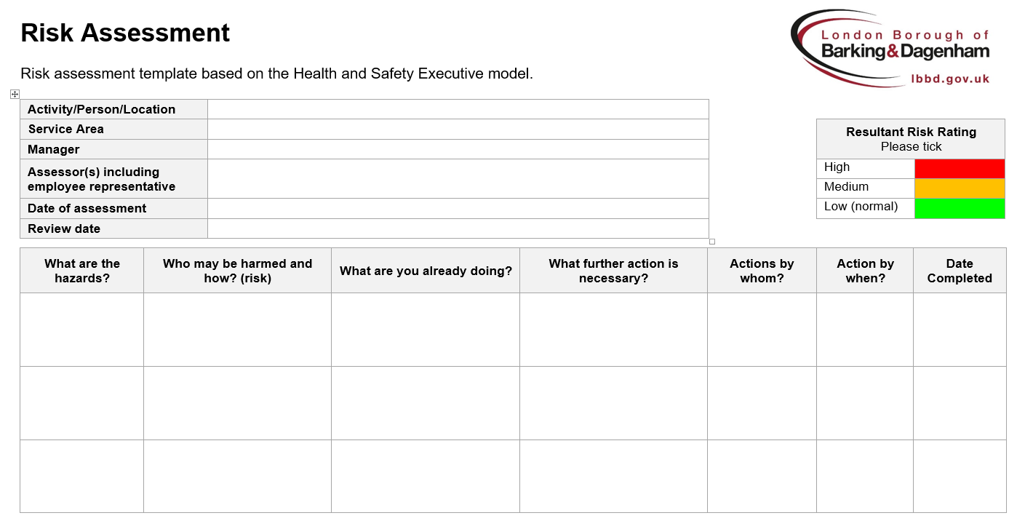

How to complete a risk assessment form
Select a risk rating to reflect the overall risk once controls are in place.
Add details of the work activity or person being assessed and location details if applicable.

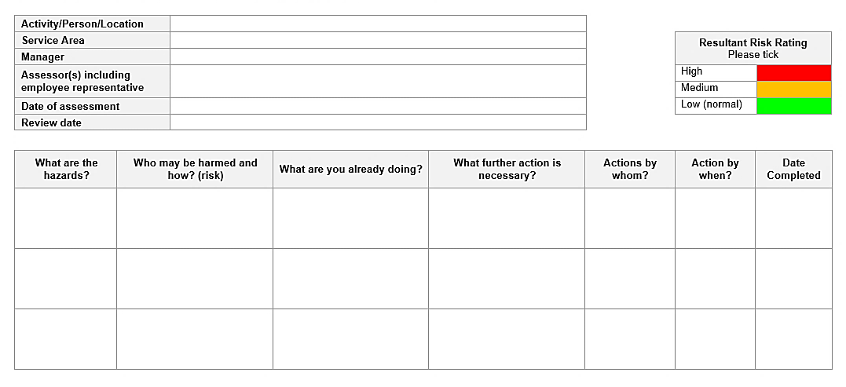
Decide on a date when the risk assessment should be reviewed or when to check that further action has been completed. At a minimum, annually).
Break down the task into it main components. This does not need to be extensive. Make a note of the hazards that may be present e.g. slippery floor.
Make a note of who could be affecting by the work activity e.g. employee’s, visitor’s and what risks they may encounter.
Note further actions which could be taken to reduce the risks to an acceptable level.

Simple steps to undertake an assessment
Make a note of any measures that are taken to reduce or remove the hazard. Make reference to other guidance, procedures or training.

The simple steps will take you through how to go about completing a risk assessment. Key Steps:

- Discuss with your team the hazards associated with their work. This could be via team meetings, one to one’s or walking around the workplace to identify hazards
- Pull together a list of hazards; think about who may be harmed as a result and how (risk)
- Formalise your assessment using the Risk Assessment Form and decide on control measures
- Circulate the draft risk assessment for comments, including employee representative
- Make necessary amendments and finalise
- Implement controls
- Evaluate, with your employees, whether the controls work
- Review your assessment at regular intervals or when changes have occurred

Risk matrix (mainly used for more complex assessments)

Most assessments will not need to use risk matrices. However, they can be used to help you work out the level of risk associated with a particular issue. They do this by categorising the likelihood of harm and the potential severity of the harm. This is then plotted in a matrix (please see below for an example). The risk level determines which risks should be tackled first.

Using a matrix can be helpful for prioritising your actions to control a risk. It is suitable for many assessments but in particular to more complex situations. However, it does require expertise and experience to judge the likelihood of harm accurately. Getting this wrong could result in applying unnecessary control measures or failing to take important ones.

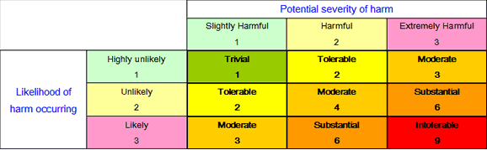

Further assessments

Some areas may need further assessment. This is usually because the work involved is more complex, because the risks may be greater or because the regulations state a detailed assessment needs to be made. More work may be needed to think of ways in which the risks can be adequately dealt with and appropriate action planned and implemented. Some areas where you may need to consider further assessment:

For schools who do not have access to the intranet, forms and further guidance can be found on the Learning Gateway or by contacting the Health and Safety Team.

Asbestos
Advice on risk assessment relating to asbestos is not contained in this guidance. Guidance is available on the intranet: https://lbbd.sharepoint.com/sites/IntTp/HR/Pages/Asbestos.aspx

Control of Substances Hazardous to Health (COSHH)
COSHH risk assessments of potentially hazardous substances need to be carried out in line with council guidance. To assist you with this requirement, COSHH assessments can be produced with the aid of the Health and Safety Executives COSHH Essential tool, see useful link below:
https://lbbd.sharepoint.com/sites/IntTp/HR/Pages/Hazardous-Substances.aspx

Using computers
For employees who work with computers for a significant part of their normal work an assessment must be made. The Display Screen Equipment assessment questionnaires are available on the intranet and should be completed by the employee together with the manager.
https://lbbd.sharepoint.com/sites/IntTp/HR/Pages/Display-Screen-Equipment.aspx

Stress
Team pressure and resilience assessments should be undertaken on a regular basis on some occasion’s individual pressure and resilience assessments should be carried out. Further information, guidance and template forms are on the intranet page.
https://lbbd.sharepoint.com/sites/IntTp/HR/Pages/Mental-Wellbeing.aspx

Fire
For those responsible for fire safety management, typically building duty holders, a fire risk assessment, including an emergency evacuation plan and a diagrammatical evacuation plan need to be developed. The Fire Steps to Fire Safety Management takes you through this process and is available on the intranet
https://lbbd.sharepoint.com/sites/IntTp/HR/Pages/Fire.aspx

Water Systems
As required by The Control of Legionella Bacteria in Water Systems 2000, a risk assessment needs to be carried out to identify the likelihood of legionella bacteria forming in any part of the buildings hot and cold water system. Further information on water safety can be found on the intranet https://lbbd.sharepoint.com/sites/IntTp/HR/Pages/Water-Systems.aspx and the duty holder support pack, see below.

Other building duty holder areas
There are other areas within building duty which may require specific risk assessment. For all topics of building duties please see the duty holder support pack.
https://lbbd.sharepoint.com/sites/IntTp/HR/Pages/Building-Duty-Holders.aspx

New and expectant mothers
Your workplace risk assessment should already consider any risks to female employees of childbearing age and, in particular, risks to new and expectant mothers (for example, from working conditions, or the use of physical, chemical or biological agents). Any risks identified must be included and managed as part of the general workplace risk assessment.

If you are notified that an employee is pregnant, breastfeeding or has given birth within the last six months, you should check your workplace risk assessment to see if any new risks have arisen. If risks are identified you must take appropriate, sensible action to reduce, remove or control them.

It is a legal obligation for employers to regularly review general workplace risks, and also, there is now a legal requirement to conduct a specific, individual risk assessment for your new and expectant mother, this will help you decide if any additional action needs to be taken.

If a significant health and safety risk is identified for a new or expectant mother, which goes beyond the normal level of risk found outside the workplace, you must take further action. Please see the http://www.hse.gov.uk/mothers/flowchart.htm which outlines the action an employer must take.

It is important to check and if necessary to update your risk assessments because the risk of damage to the unborn child may rise at different stages of a pregnancy from any process, prolonged sitting or standing, working condition or physical, biological or chemical agents. For example, your mobility, dexterity, agility, co-ordination, speed of movement and reach may be impaired because of your increased size as the pregnancy progresses.

For a comprehensive list of the Health and Safety Executives Frequently Asked Questions relating to new and expectant mothers please follow: http://www.hse.gov.uk/mothers/faqs.htm#q19

Your risk assessment must specifically consider any risks to the health and safety of a new or expectant mother, or that of her baby. Possible risks include:

Physical agents
- Movements and postures
- Manual handling
- Shocks and vibrations
- Noise
- Radiation (ionising and non-ionising)
- Compressed air and diving

Biological agents
- Infectious diseases

Chemical agents
- Toxic chemicals
- Mercury
- Antimitotic (cytotoxic) drugs
- Pesticides
- Carbon monoxide
- Lead

Working conditions
- Facilities (including rest rooms)
- Mental and physical fatigue, working hours
- Stress (including post-natal depression)
- Passive smoking
- Temperature
- Working with visual display units
- Working alone
- Working at height
- Travelling
- Violence
- Personal protective equipment
- Nutrition

Risk Assessment Checklist for New and Expectant Mothers

Problems/ working conditions | Nature of the risk | What to look out for
Movement and posture and manual handling | A variety of factors linked to pace of work, rest breaks, work equipment and the work area can be involved.  Hormonal changes during and shortly after pregnancy affect ligaments and can increase chances of injury. Postural problems may get worse as pregnancy advances.  Standing in one position for long periods can cause dizziness, faintness and fatigue. It can also increase chances of premature birth or miscarriages. Sitting for long periods increases the risk of thrombosis. Backache is also associated with long periods of standing or sitting.  Restrictive work space may be a problem particularly in the latter stages of pregnancy. | - Does the employee have to stand for periods of more than two-three hours without a break?  - Does the employee have to sit for periods of more than two-three hours?  - Can the equipment and workstation be adjusted to fit the employee?  - Does the job involve awkward twisting or stretching?  - Are there space restrictions? Will these cause more restricted movement as the pregnancy develops?  - Does the job involve rapid repetitive lifting (even of lighter objects)?  - Does the job involve lifting objects that are difficult to grasp or are awkward to hold?
Protective equipment and uniforms | Protective clothing or other types of Personal Protective Equipment (PPE) are not generally designed for use by pregnant employees. Physical changes around pregnancy may make it too uncomfortable to wear, or may mean that it no longer provides the intended protection. | - If the employee has to wear protective aprons/overalls etc, are they provided in suitable sizes?  - Are the materials used comfortable for all pregnant employees to wear?
Hazardous substances – infection risks and chemicals | There are over 200 industrial chemicals that can cause harm to an unborn child. Many solvents may also contaminate breast milk. | - Are hygiene precautions adequate?  - Are there any chemicals at work known to be a risk?  - Are pregnant employees kept away from jobs that could increase exposure, for example, industrial solvents?
Working time | Long hours, and unsocial shift work can affect the health of pregnant employees and can disrupt breast-feeding. | - Is the employee expected to work long hours/overtime?  - Does the employee have some flexibility or choice over her working hours?  - Does the work involve very early starts or very late finishes?  - Does the job involve night work?
Work related stress | New and expectant mothers can be vulnerable to stress because of hormonal, psychological and physiological changes around pregnancy.  Additional stress may occur if the employee has reason to be anxious about her pregnancy. | - Are colleagues and supervisors supportive towards the pregnant employee?  - Is the employee aware of what to do if she feels she is being bullied or victimised?  - Has the risk assessment taken account of any concerns the employee has about her pregnancy?
Extreme of cold or heat | Pregnant women are less able to tolerate heat or extreme cold. | - Does the work involve exposure to temperatures that are uncomfortably cold (below 16 degrees C) or hot (above 27 degrees C)?  - If protective clothing is provided against the cold is suitable for the pregnant employee?  - Is the employee exposed to cold draughts even where the average temperature is acceptable?
Working at heights | Because of the risk of fainting and high blood pressure it is hazardous for pregnant employees to work at heights. | - Does the work involve a lot of climbing up and down steps or ladders?  - Does the work involve carrying items or boxes up or down ladders?  - If a mobile work platform is used to access the higher levels, is there enough room for a pregnant employee to use it safely?
Welfare issues | Rest Facilities: Rest is particularly important for new and expectant mothers.  Hygiene: Easy Access to toilets is essential to protect against risks of infection and kidney disease.  Storage facilities: Appropriate arrangements for expressing and storing breast milk may be needed for breastfeeding mothers. | - Is there somewhere quiet for pregnant employees to rest?  - Are they given easy access to toilets and more frequent breaks than other workers if needed?  - Is there a clean, private area for breast-feeding employees to express breast milk?  - Is there somewhere safe for them to store the expressed milk?

Frequently asked questions (FAQ’s)

Please follow the Health and Safety Executive’s website for a comprehensive list of FAQs’ http://www.hse.gov.uk/risk/faq.htm.

Useful contacts

Council intranet site
Information on all health, safety and wellbeing matters.
https://lbbd.sharepoint.com/sites/IntTp/HR/Pages/OHandHS.aspx

HR Service Centre
To assist you with your health, safety and wellbeing queries
020 8724 5233
HR Portal: https://lbbd.sharepoint.com/sites/HRSD/Pages/Service-Catalogue.aspx

Training
Information on health, safety and wellbeing training.
020 8227 3573
learningdevelopment@lbbd.gov.uk

Health and Safety Executive
www.hse.gov.uk

Contact us
Please see the Occupational Health, Safety and Wellbeing section on the Councils intranet for further information or advice on health, safety and wellbeing matters. For schools employees information can be found on the Learning Gateway. Alternatively, please contact the HR Service Centre on 020 8724 5233.

For health, safety and wellbeing training please email learningdevelopment@lbbd.gov.uk or call 020 8227 3573.

